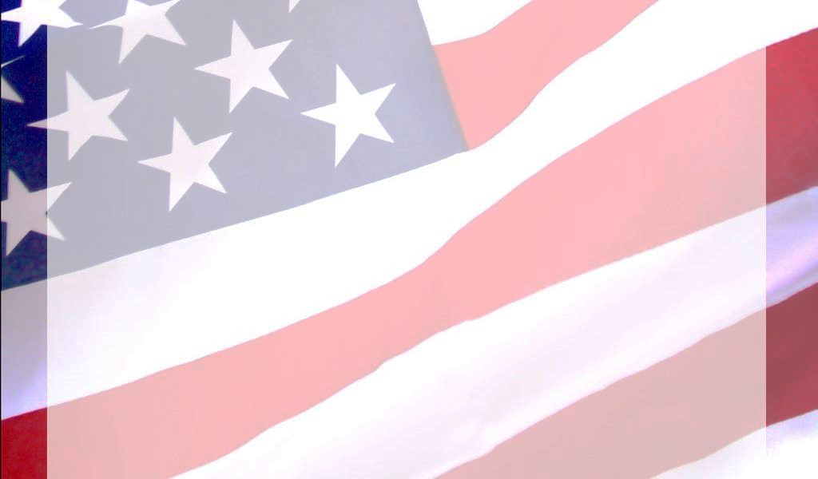

**2022**

**Bill Stephens 4th of July Americana Parade Entry Form**

**City of Sopchoppy: PO Box 1219, Sopchoppy, FL 32358**

**Primary Contact(s): ___________________________________________ Type of Entry (Please Check All That Apply):**

**Email: ________________________________________________________ _____Float(s)**

**Phone: _______________________________________________________ _____Walking Group**

**Address: _____________________________________________________ _____Animal(s) (type): _________ (#): _____________**

**Name of Entry: _______________________________________________ _____Vehicle(s) (type): _________ (#): _____________**

**Estimate of overall length of entry in feet: __________**

**Prize Categories: (Most Original; Best Decorated Float; Most Patriotic; Best Vintage Automobile).**

**Please note: For the protection and convenience of all parade participants, animal entries must also include a dedicated person**

**who will provide real time cleanup of any droppings.**

**Please fill out this application along with a short bio to be announced by the Emcee and submit before Monday, June 20, 2022. Applications can be sent**

**via mail to City of Sopchoppy, P.O. Box 1219 Sopchoppy, FL 32358, in person at 105 Municipal Ave., Sopchoppy, FL 32358 or by fax (850)962-3429.**

**Entries will receive placement on a first-come, first-served basis. The parade will commence downtown Sopchoppy on Monday, July 4th at 10 a.m.**

**Parade lineup begins at 9:00 a.m.**

**Short Bio (5-10 Seconds) to be announced by Emcee:**